- Write a program to print Right Triangle Star Pattern
Sample Input:: n = 5
Program:
class PyramidPattern
{
public static void Triangle(int n)
{
int i,j;
for (i=0;i<n;i++)
{
for (j=0;j<=i;j++)
{
System.out.print("* ");
}
System.out.println();
}
}
public static void main(String args[])
{
int k=5;
Triangle(k);
}
}
Output:
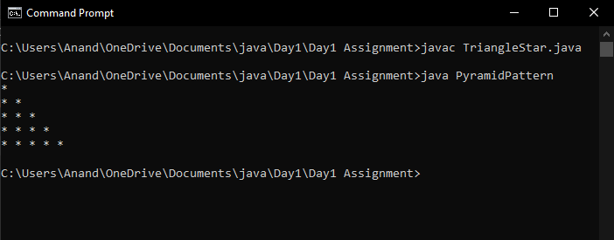

2. Write a program to print the below pattern?
1
1 1
1 2 1
1 3 3 1
- 4 6 4 1
Program:
class Main
{
public static void main(String[] args)
{
int rows = 5, coef = 1;
for(int i = 0; i < rows; i++)
{
for(int space = 1; space < rows - i; ++space)
{
System.out.print(" ");
}
for(int j = 0; j <= i; j++)
{
if (j == 0 || i == 0)
coef = 1;
else
coef = coef * (i - j + 1) / j;
System.out.printf("%4d", coef);
}
System.out.println();
}
}
}
Output:
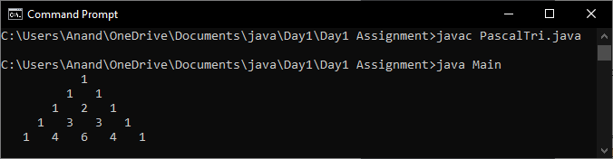

- Write a program to print rectangle symbol pattern. Get the symbol as input from user
Program:
import java.util.Scanner;
class RectangleStar
{
private static Scanner sc;
public static void main(String[] args)
{
int rows, columns, i, j;
sc = new Scanner(System.in);
System.out.print(" Please Enter Number of Rows : ");
rows = sc.nextInt();
System.out.print(" Please Enter Number of Columns : ");
columns = sc.nextInt();
for(i = 1; i <= rows; i++)
{
for(j = 1; j <= columns; j++)
{
System.out.print("* ");
}
System.out.print("\n");
}
}
}
Output:
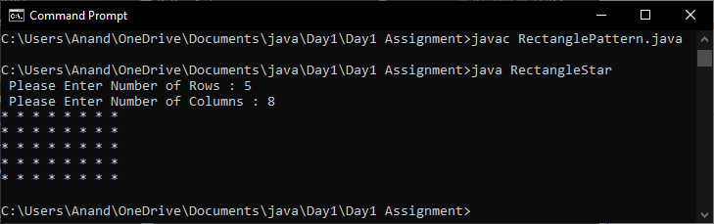

- Write a program to print the following pattern
Sample Input:
Enter the number to be printed: 1
Max Number of time printed: 3
1
11
111
11
1
Program:
import java.util.Scanner;
class Pattern1
{
public static void main(String[] args)
{
Scanner sc = new Scanner(System.in);
System.out.println("Enter the number of rows: ");
int rows = sc.nextInt();
for (int i = 0; i <= rows - 1; i++)
{
for (int j = 0; j <= i; j++)
{
System.out.print("1" + " ");
}
System.out.println("");
}
for (int i = rows - 1; i >= 0; i--)
{
for (int j = 0; j <= i - 1; j++)
{
System.out.print("1" + " ");
}
System.out.println("");
}
sc.close();
}
}
Output: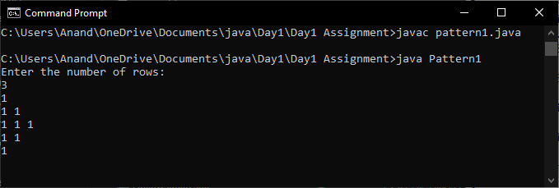

- Write a program to print the Inverted Full Pyramid pattern?
Program:
class Pattern
{
public static void main(String[] args)
{
int rows = 5;
for(int i = rows; i >= 1; --i)
{
for(int space = 1; space <= rows - i; ++space)
{
System.out.print(" ");
}
for(int j=i; j <= 2 * i - 1; ++j)
{
System.out.print("* ");
}
for(int j = 0; j < i - 1; ++j)
{
System.out.print("* ");
}
System.out.println();
}
}
}
Output:
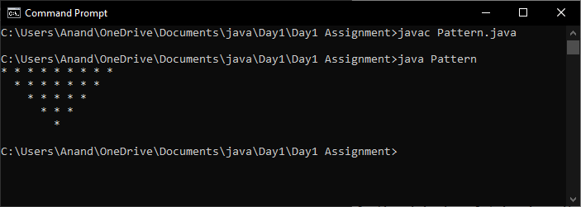

- Write a program to print the following pattern
Sample Input:
Enter the Character to be printed: %
Max Number of time printed: 3
%
% %
% % %
Program:
class Patternpercent
{
public static void Triangle(int n)
{
int i,j;
for (i=0;i<n;i++)
{
for (j=0;j<=i;j++)
{
System.out.print("% ");
}
System.out.println();
}
}
public static void main(String args[])
{
int k=3;
Triangle(k);
}
}
Output:
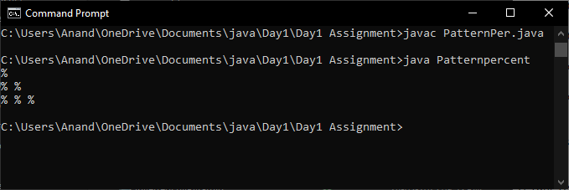

- Write a program to print hollow square symbol pattern?
Program:
import java.util.Scanner;
class HollowSquare1
{
private static Scanner sc;
public static void main(String[] args)
{
sc = new Scanner(System.in);
System.out.print("Enter Hollow Square Side = ");
int side = sc.nextInt();
System.out.println("Printing Hollow Square Star Pattern");
for (int i = 0; i < side; i++ )
{
for (int j = 0 ; j < side; j++ )
{
if (i == 0 || i == side - 1 || j == 0 || j == side - 1)
{
System.out.print("*");
}
else
{
System.out.print(" ");
}
}
System.out.println();
}
}
}
Output:
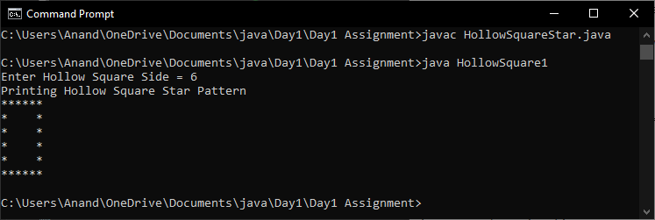

- Write a program to print the below pattern
1
2 2
3 3 3
4 4 4 4
Program:
import java.util.*;
class Numpattern
{
public static void main(String[] args)
{
int i, j, rows;
Scanner sc = new Scanner(System.in);
System.out.print("Enter the number of rows you want to print: ");
rows = sc.nextInt();
for (i = 1; i <= rows; i++)
{
for (j = 1; j <= i; j++)
{
System.out.print(i+" ");
}
System.out.println();
}
}
}
Output:
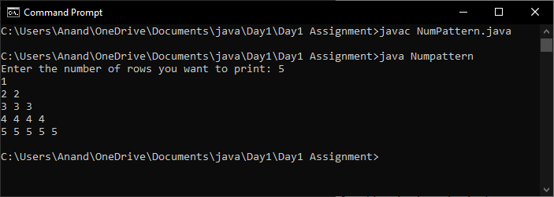

- Write a program to print the below pattern
1
4 9
16 25 36
49 64 81 100
Program:
class series
{
public static void main(String[]args)
{
int i,j;
for(i=1; i<=10; i++)
{
j=i*i;
System.out.println(j);
}
}
}
Output:
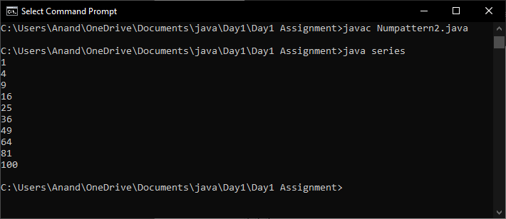

- Write a program to print the below pattern
1
2 2
3 3 3
4 4 4 4
3 3 3
2 2
1
Program:
class pattern
{
public static void main(String[] args)
{
int i,j;
for(i=1;i<5;i++)
{
for(j=1;j<=i;j++)
{
System.out.print(i+" ");
}
System.out.println();
}
for(i=3;i>0;i--)
{
for(j=i;j>0;j--)
{
System.out.print(i+" ");
}
System.out.println();
}
}
}
Output:
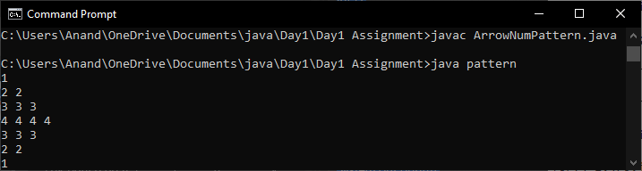
- Write a program to print hollow Square Dollar pattern?
Program:
import java.util.Scanner;
class HollowSquare2
{
private static Scanner sc;
public static void main(String[] args)
{
sc = new Scanner(System.in);
System.out.print("Enter Hollow Square Side = ");
int side = sc.nextInt();
System.out.println("Printing Hollow Square Star Pattern");
for (int i = 0; i < side; i++ )
{
for (int j = 0 ; j < side; j++ )
{
if (i == 0 || i == side - 1 || j == 0 || j == side - 1)
{
System.out.print("$");
}
else
{
System.out.print(" ");
}
}
System.out.println();
}
}
}
Output:
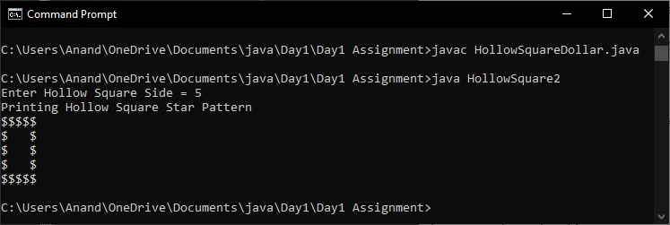

- Write a program to print inverted pyramid pattern.
Input: no of rows: 3
Output
*****
***
*
Program:
import java.io.*;
class Invertedpy
{
public static void main(String[] args)
{
int number = 3;
int i = number, j;
while (i > 0)
{
j = 0;
while (j++ < number - i)
{
System.out.print(" ");
}
j = 0;
while (j++ < (i * 2) - 1)
{
System.out.print("*");
}
System.out.println();
i--;
}
}
}
Output:
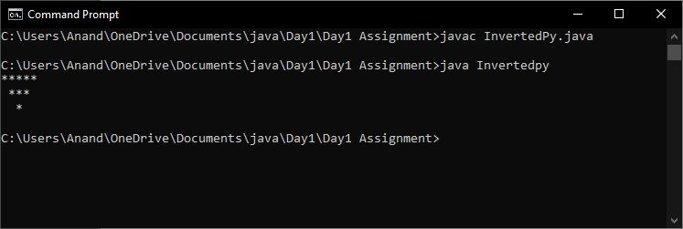

- Write a program for matrix multiplication?
Sample Input:
Mat1 = 1 2
5 3
Mat2 = 2 3
4 1
Sample Output:
Mat Sum = 10 5
22 18
Program:
class MatrixMul
{
public static void main(String args[])
{
int a[][]={{1,1,1},{2,2,2},{3,3,3}};
int b[][]={{1,1,1},{2,2,2},{3,3,3}};
int c[][]=new int[3][3];
for(int i=0;i<3;i++)
{
for(int j=0;j<3;j++)
{
c[i][j]=0;
for(int k=0;k<3;k++)
{
c[i][j]+=a[i][k]*b[k][j];
}
System.out.print(c[i][j]+" ");
}
System.out.println();
}
}
}
Output:
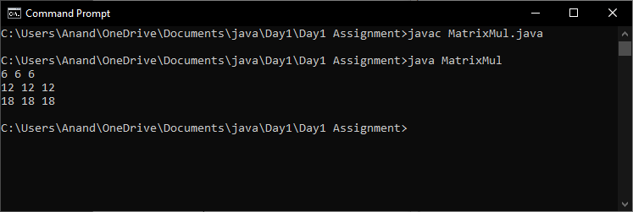

- Write a program for matrix addition?
Sample Input:
Mat1 = 1 2
5 3
Mat2 = 2 3
4 1
Sample Output:
Mat Sum = 3 5
- 4
Program:
class MatrixAdd
{
public static void main(String args[])
{
int a[][]={{1,3,4},{2,4,3},{3,4,5}};
int b[][]={{1,3,4},{2,4,3},{1,2,4}};
int c[][]=new int[3][3];
for(int i=0;i<3;i++)
{
for(int j=0;j<3;j++)
{
c[i][j]=a[i][j]+b[i][j];
System.out.print(c[i][j]+" ");
}
System.out.println();
}
}
}
Output:
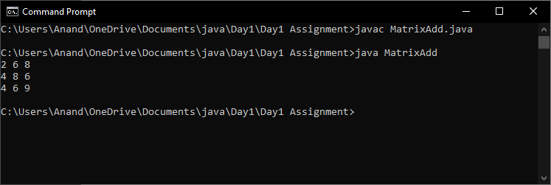

- Find the Mean, Median, Mode of the array of numbers?
Sample Input;:
Array of elements = {16, 18, 27, 16, 23, 21, 19}
Sample Output:
Mean = 20
Median = 19
Mode = 16
Program:
import java.io.*;
import java.lang.*;
class Mean
{
public static void main(String[] args)
{
int[] invalue = new int[]{2,4,5,2,6};
int num_value=5;
double tot=0;
double mean=0;
for(int i=0; i<num_value; i++)
{
tot = tot+invalue[i];
}
mean = tot/num_value;
System.out.println("The mean value is: "+mean);
double median = 0;
double mid=0;
if(num_value%2 == 0)
{
int temp=(num_value/2)-1;
for(int i=0;i<num_value;i++)
{
if(temp==i || (temp+1)==i)
{
mid=mid+invalue[i];
}
}
mid=mid/2;
System.out.println("Median value is: "+mid);
}
else
{
int temp=(num_value/2);
for(int i=0;i<num_value;i++)
{
if(temp==i)
{
mid=invalue[i];
System.out.println("Median value: "+mid);
}
}
}
int i,j,z, tmp, maxCount, modeValue;
int[] tally=new int[num_value];
for(i=0;i<num_value;i++)
{
for(j=0;j<num_value-i;j++)
{
if(j+1!=num_value)
{
if(invalue[j]>invalue[j+1])
{
tmp=invalue[j];
invalue[j]=invalue[j+1];
invalue[j+1]=tmp;
}
}
}
}
for (i = 0; i < num_value; i++)
{
for(z=i+1;z<num_value;z++)
{
if(invalue[i]==invalue[z])
{
tally[i]++;
}
}
}
maxCount = 0;
modeValue = 0;
for (i = 0; i <num_value; i++)
{
if (tally[i] > maxCount)
{
maxCount = tally[i];
modeValue = invalue[i];
}
}
System.out.println("Mode value is :"+modeValue);
}
}
Output:
